
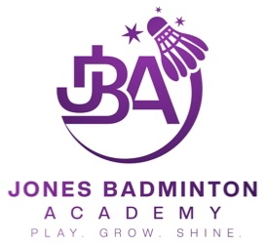

Safeguarding & Wellbeing At:
Jones Badminton Academy
When we talk about ‘safeguarding’ we mean the measures that are put in place, and the actions that are taken, to support the physical and emotional welfare of everyone involved in badminton and protect them from harm.

It doesn’t matter how old you are or what your role is. We want everyone to have a safe and positive experience at Jones Badminton Academy

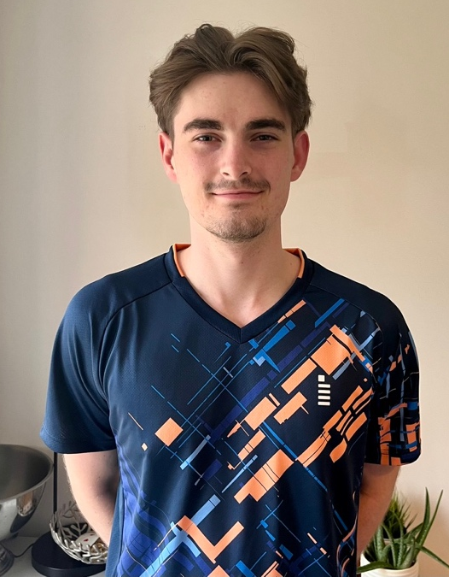
Getting Advice:

Safeguarding is everyone’s responsibility, and it is important for you to know that you can talk to any of us at Jones Badminton Academy

Samuel Jones (Director and Head Coach) is our appointed Club Welfare Officer and Designated Safeguarding Lead (DSL)

Emily Collinson (Assistant Coach) is our Deputy Designated Safeguarding Lead (DDSL)

There are several ways to get in touch with Samuel and Emily

Email: sam@jonesbadmintonacademy.co.uk safeguarding@jonesbadmintonacademy.co.uk
In person: at any one of our sessions
What you can expect from us:

A safe environment – we have policies, procedures and guidelines in place that everyone must follow.

Education – coaches at Jones Badminton Academy will receive regular training to ensure they understand their safeguarding responsibilities. We also have a responsibility to educate you – our members - helping you to understand where you can get help and advice if needed.

Action - we will not lose sight of the importance of ensuring welfare and wellbeing is central to Jones Badminton Academy. We have a duty to take all concerns seriously and we will ensure that anything shared with us is dealt with appropriately and passed on to those who know how to provide the best support possible.

Your Club Welfare Officer will provide support and listen to any of your concerns which could relate to:

- Wellbeing concerns - physical and/or emotional
- You experiencing, observing or hearing about abuse and/or poor practice
- Behaviour that is a breach of the Codes of Conduct
- Bullying
- Something that just doesn’t feel right

At Jones Badminton Academy we will follow the Safeguarding Policies of Badminton England, work to best practice guidelines and respond swiftly to any concerns.

We will seek support from the Badminton England Safeguarding Team when necessary.

You can find more details about the work of the Badminton England Safeguarding Team here:

https://www.badmintonengland.co.uk/about-us/safeguarding/
Useful Contacts
Welfare and wellbeing are important to us –
you may also find the following contacts useful:



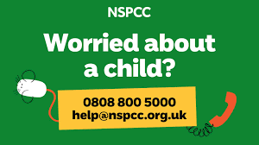
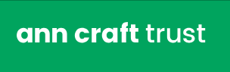
YOUNGMINDS provide mental health support for children and young people.
www.youngminds.org.uk

Mind provide information and support to those living with a mental health problem or supporting someone who is.
www.mind.org.uk

You can contact the NSPCC Helpline 10am-6pm Monday to Friday.
You can email them at any time.
www.nspcc.org.uk

The Ann Craft Trust are the leading UK authority on Safeguarding Adults.
www.anncrafttrust.org

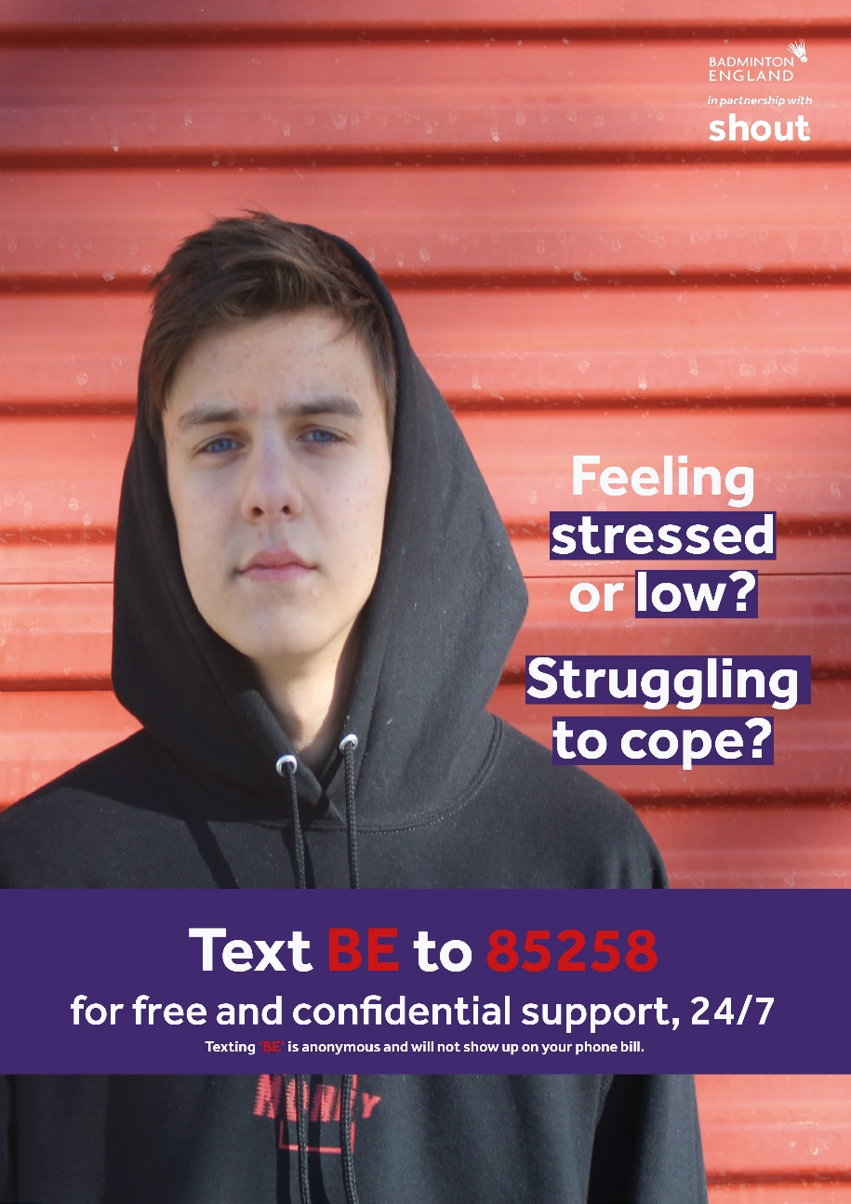
Shout offer free and confidential mental health text support for anyone in our badminton community. Their volunteers are there for you any time of day or night, 365 days a year.

The service can be used at any time by texting “BE” to 85258

